**Teleprompter**

Install nodejs from <https://nodejs.org/dist/v23.6.0/node-v23.6.0-x64.msi>

Use Casparcg server from here <https://drive.google.com/file/d/1V1LZWQmss2O4gqG5wVSHLuW2J9Y8SDoj/view?usp=drive_link>

Unzip the software with 7z <https://7-zip.org/a/7z2409-x64.exe>

Double click start Prompter.bat file from unzipped teleprompter folder

Open <http://localhost:3000> in browser

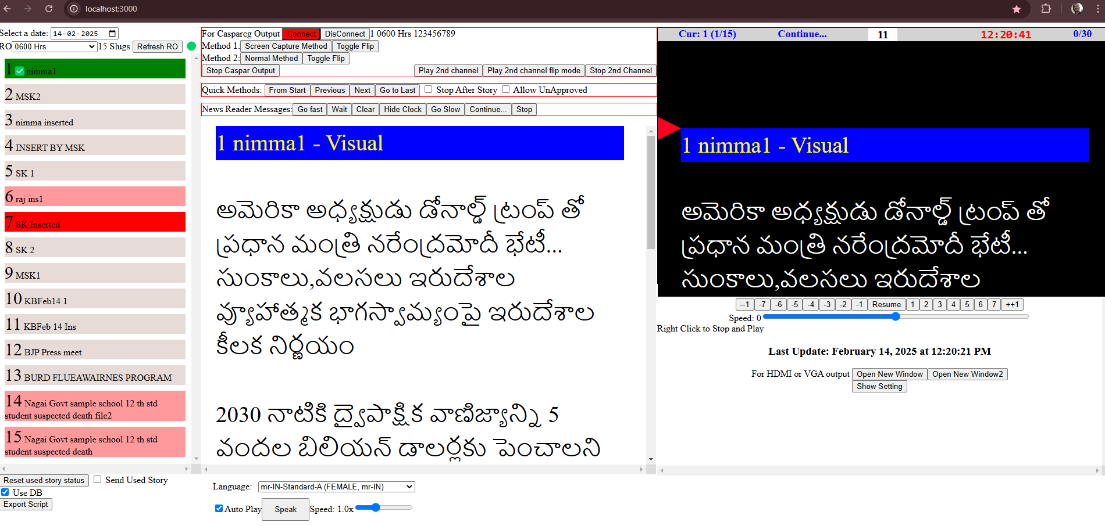

Select date, runorder name, double click on required slug name, and click on required speed like 1 to start. Right click to stop and play with previous speed.

Teleprompter can be seen vertically scrolling on screen in the software itself.

1. Output can be found by clicking ‘open new window’ button. That will open a new window with teleprompter content, Then Drag it to second screen, maximize it by double clicking on title bar, then double clicking in the content. Right click to flip, again right click or double click to un-flip.

2. Casparcg output can be found by either clicking on ‘Screen Capture Method’ button or ‘Normal Method’ button. We need to double click required slug again for casparcg output in Normal Method. Click ‘Toggle flip’ button to flip and again click to unflip.

3. Software should be in maximized state, in active tab, and nothing should be there over it.

4. Setting of Database IP, Database name and Caspar IP are in .env.local file.

5. Setting of Font size and start position can be done by clicking show setting button.

6. Teleprompter can be used by from text file also. For this uncheck the useDB button and choose a text file.

7. Shuttle pro setting should be imported from file in teleprompter folder ShuttleProSettingsForGoogle Chrome.pref file.

